Cleaning & Disinfecting Transport Vehicles

When transporting animals, it is important to have thorough sanitation procedures to promote animal health and safety. All vehicles used during transport must be cleaned and disinfected after each use. Our step-by-step guide will show you techniques for sanitizing transport vehicles.

Supply List
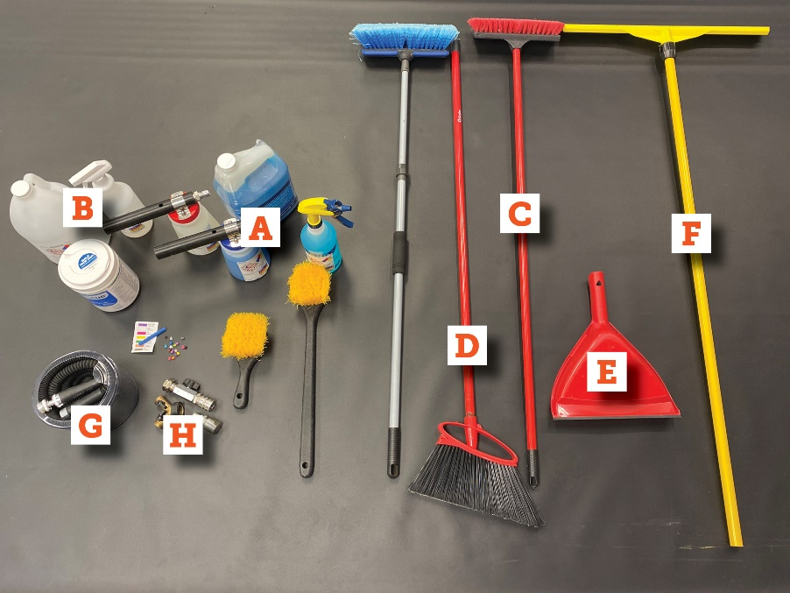 | - Hose-end foamer filled with detergent*  (with secondary labeling)  - Hose-end foamer filled with disinfectant*  (with secondary labeling)  - Deck brush  - Broom  - Dustpan  - Squeegee  - Hose with quick disconnect attachment  - Sprayer nozzle  - Disposable gloves (not pictured)  - Trash bag (not pictured)  *Note: A pump sprayer with diluted disinfectant solution or detergent can be used if a garden hose is not available.

Cleaning & Disinfecting Steps
- Park and position vehicle
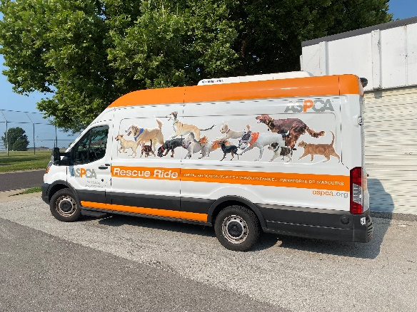 | - Park vehicle on incline (if possible).  - Having the rear lower than the front will help drain the water and sanitizing solutions.

- Remove all crates and supplies from vehicle
  - Place items a sufficient distance from vehicle to avoid overspray.

- Remove organic material and trash
  - Put on disposable gloves.
  - Remove any remaining organic material and trash and place in trash bag.

- Sweep vehicle
  - Sweep emptied vehicle to remove any smaller items.

- Rinse vehicle with water
  - Using hose, thoroughly rinse vehicle.
  - Be sure to include floor, ceiling, and walls.

- Position crate restraining systems or straps
  - If the vehicle contains built-in crate restraining system, be sure to position it so that it can be thoroughly rinsed and sanitized.
  - If tie down or ratchet straps were used, remove from vehicle to be sanitized separately.

- Coat surfaces with detergent solution
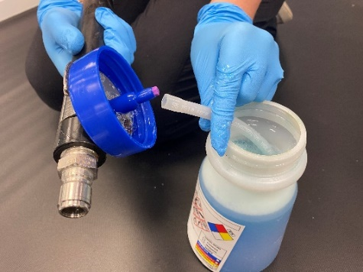 | - Insert desired dilution tip (see photo) in the hose-end foamer with detergent.  - Coat all surfaces of vehicle with detergent solution.  - Don't forget floor, ceiling, and walls.  - While inside truck, close doors and coat them with detergent solution.

- Scrub vehicle surfaces
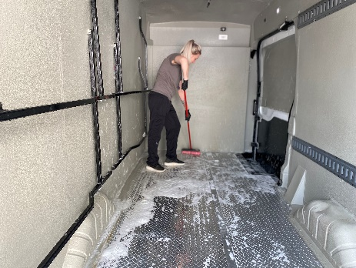 | 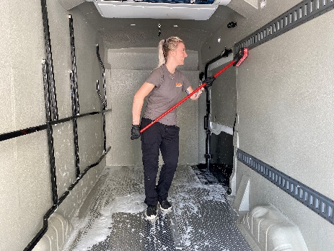 | 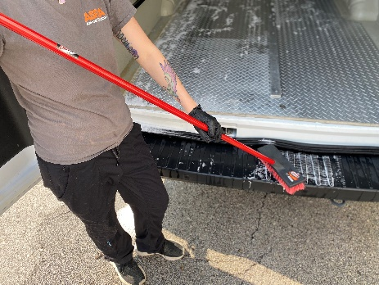

  - Scrub all vehicle surfaces with deck brush until all organic material is removed.
  - Scrub the ceiling, walls, doors, floor, and steps into vehicle.
  - Ensure all organic matter is loosened prior to rinsing and disinfecting.

- Rinse detergent with water
  - Attach spray nozzle and rinse detergent with water until all soap is removed.
  - Be sure to rinse all corners, walls, floor, steps, and the doors.
  - Rinse deck brush thoroughly in preparation for disinfection.

- Coat surfaces with disinfectant foam
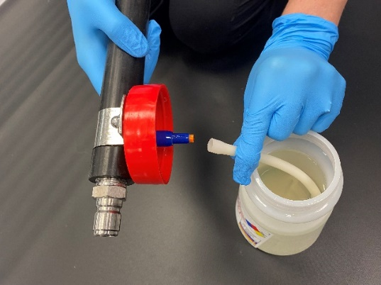 | - Insert desired dilution tip (see photo) in the hose-end foamer with disinfectant.  - Hold the foamer in upright position and coat all surfaces of vehicle with disinfectant.  - Don't forget corners, ceiling, walls, floor, steps, and the doors.  - If a garden hose is not available, use a pump sprayer with diluted disinfectant solution.

- Allow contact time
  - Allow contact time based on the type and concentration of disinfectant solution applied (typically a minimum of 10 minutes).

- Rinse vehicle with clean water
  - Attach spray nozzle and rinse vehicle with water until all residue is removed.
  - Rinse vehicle corners, ceiling, walls, floor, steps, and interior of doors.

- Squeegee excess water
  - Moving from front to rear, squeegee excess water and disinfectant solution out of vehicle.

- Load crates back into vehicle
  - Once the vehicle and crates are clean and disinfected, load the crates back into the vehicle.
  - Turn the fan on high and shut the doors to speed the drying process.
  - Ensure vehicle and crates are completely dry before re-loading animals.


