Cleaning & Disinfecting Transport Crates

When transporting animals, it is important to have thorough sanitation procedures to promote animal health and safety. All crates used during transport must be cleaned and disinfected after each use. Our step-by-step guide will show you techniques for sanitizing transport crates.

Supply List
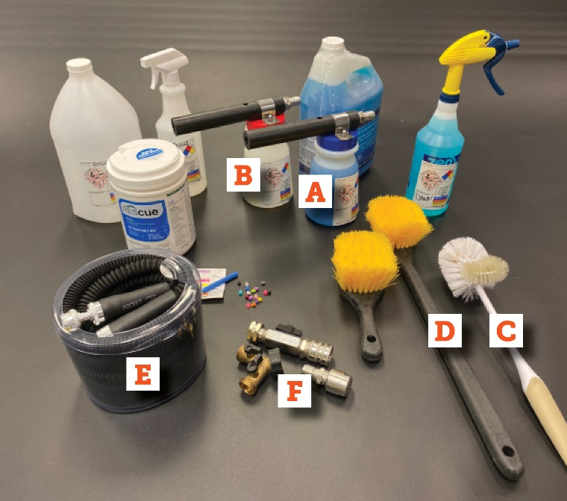 | - Hose-end foamer filled with detergent*  (with secondary labeling)  - Hose-end foamer filled with disinfectant*  (with secondary labeling)  - Rounded toilet brush  - Long-handled scrub brush  - Hose with quick disconnect attachment  - Sprayer nozzle  - Disposable gloves (not pictured)  - Trash bag (not pictured)  *Note: A pump sprayer with diluted disinfectant solution or detergent can be used if a garden hose is not available.

Cleaning & Disinfecting Steps
- Remove bedding and organic materials
  - Put on disposable gloves.
  - Remove all bedding and organic materials (food, feces, etc.) and dispose in trash.

- Remove crates from the vehicle
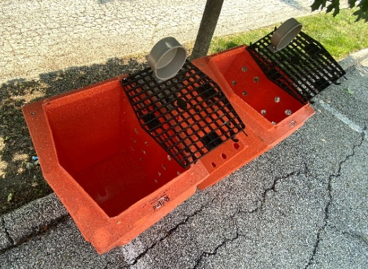 | - ALL crates must be removed even if they did not have an animal in them.  - Position crates to allow drainage (see photo).  - Remove bowls or position to allow drainage.

- Rinse crates with water
  - Thoroughly rinse crates, making sure to rinse doors, bowls, and all corners to remove debris.
  - Don’t forget to lift and rinse the bottom of each crate.

- Coat surfaces with detergent solution
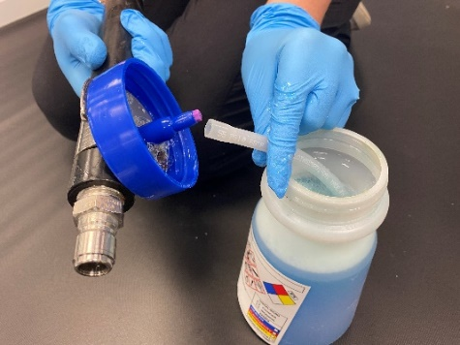 | - Insert desired dilution tip (see photo) in the hose-end foamer with detergent.  - Coat all surfaces of the crates with detergent solution.  - Don't forget corners, doors, and bowls.

- Scrub crate surfaces
  - Scrub all crate surfaces to remove any remaining organic material.
  - Use the toilet brush to scrub corners and bowls, and the long-handled brush to reach into the back of
larger crates.
  - Ensure all organic matter is loosened prior to rinsing and disinfecting.

- Rinse detergent with water
  - Attach spray nozzle and rinse detergent with water until all soap is removed.
  - Reach into each crate and rinse all the corners, the door, and the water bowl.
  - Rinse scrub brushes thoroughly in preparation for disinfection.

- Coat crate surfaces with disinfectant foam
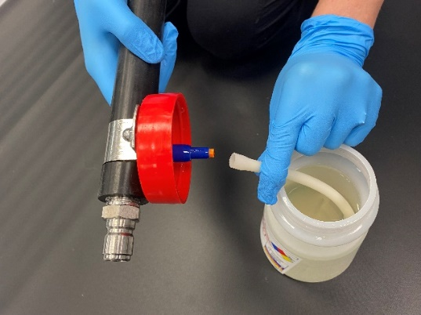 | - Insert desired dilution tip (see photo) in the hose-end foamer with disinfectant.  - Hold the foamer in an upright position and coat all surfaces of the crates with disinfectant.  - Remember to also coat scrub brushes.

- Allow contact time
  - Allow contact time based on the type and concentration of disinfectant solution applied (typically a minimum of 10 minutes).

- Rinse crates with clean water
  - Attach spray nozzle and rinse crates with water until all residue is removed.
  - Reach into each crate and rinse all the corners, the door, and the water bowl.
  - Flip the crates over with the door down to drain excess water.

- Load crates into vehicle
  - Load the clean crates back into the vehicle.
  - Turn the fan on high and shut the doors to speed the drying process.
  - Ensure crates are completely dry before re-loading animals.

